**Annual performance report for: Stericycle Sidcup Waste to Energy Facility.**

**Permit Number: EPR/JP3133XP**

**Year: 2022**

This report is required under the Industrial Emissions Directive’s Article 55(2) requirements on reporting and public information on waste incineration plants and co-incineration plants, which require the operator to produce an annual report on the functioning and monitoring of the plant and make it available to the public.

**1. Introduction**

|  |  |
| --- | --- |
| Name and address of plant | SRCL Limited  Queen Marys Hospital  Frognal Avenue  Sidcup  Kent.  DA14 6LT |
| Description of waste input | The plant at Sidcup incinerates clinical waste, including clinical waste classed as hazardous under the Hazardous Waste Regulations 2005.The bulk of the waste is produced at Hospitals, but also includes lesser quantities from Doctors practices, Dental Practices, Health Clinics, Residential and Nursing Homes and from Medical Research Facilities. The Hazardous wastes Incinerated Includes infectious waste and waste containing Cytotoxic and Cytostatic medicines.  The plant also incinerates small quantities of specialised waste. |
| Operator contact details if members of the public have any questions | SRCL Limited  Indigo House  Sussex Avenue  Leeds  LS10 2LF |

**2. Plant description**

|  |
| --- |
| The plant is a clinical waste incinerator of the pulsed hearth type. It is designed to process 1000 kilograms per hour. Healthcare wastes are loaded mechanically direct from wheeled bins in which it arrives at site into the loading hopper, once here the waste is visually inspected, and any non-conformant waste can be identified, intercepted and reported as per company procedures. Errors in waste content are flagged for follow up with the waste producer. Once inspection is complete the waste is charged into the incinerator where the combustion process commences. The waste is burnt at a minimum temperature of 850 degrees Celsius and burns out to produce an ash. The residue ash then drops into an ash quench pit and once cooled is mechanically transferred to a skip.  The flue gases from the incineration process pass through a secondary chamber where any gaseous products of combustion are reburned in an oxygen rich environment. This stage is designed to destroy any carbon monoxide, volatile organic compounds, dioxins and furans produced during the combustion process. The flue gases are then cooled by passing them through a waste-heat boiler and economiser. before passing into the final, abatement section of the process. Powdered Lime (Calcium Hydroxide) and powdered activated Carbon are added to the flue gases entering the abatement section and here Acid gases, Heavy Metals, Residual Dioxins and Furans are removed before being discharged from the stack.  The flue gases being discharged from the stack are continuously monitored for Hydrogen Chloride, Sulphur Dioxide, Carbon Monoxide, Oxides of Nitrogen, Particulate Matter (Dust), Volatile Organic Compounds, Oxygen, Ammonia and Nitrous Oxide.  The incineration process produces two residues. Bottom Ash and Spent Lime. |

**3. Summary of Plant Operation**

**3.1 Summary of plant operation**

|  |  |  |
| --- | --- | --- |
| Hazardous waste received | 3050 | tonnes |
| Non-Hazardous Waste. | 2125 | tonnes |
| Cytotoxic Waste. | 75 | tonnes |
| Total waste received | 4666 | tonnes |
| Total plant operational hours | 6,161 | hours |
| Total hours of “abnormal operation” (see permit for definition) | 390 | minutes |
| Total quantity of incinerator bottom ash (IBA) produced | 694 | tonnes. |
| Disposal or recovery route for IBA | D1 Landfill. | |
| Did any batches of IBA test as hazardous? If yes, state quantity | None | |
| Total quantity of air pollution control (APC) residues produced | 255 | tonnes |
| Disposal or recovery route for APC residues | D13 - Blending or mixing prior to submission to any of the operations numbered D1 to D12 | |
| Total heat produced for export (e.g. to hospital or district heating scheme) | 6770 | MWh |

**3.2 Annual performance parameters**

**Waste Disposal and Recovery**

|  |  |  |  |  |  |  |  |  |
| --- | --- | --- | --- | --- | --- | --- | --- | --- |
| **Waste** | Disposal | | Recovery |  | Trends in Waste Disposal and Recovery | | | |
|  | Route | Tonnes | Tonnes |  |  |  | | |
|  |  |  |  |  | Year | Named | Total | Waste per unit output |
| Waste | Waste |
| 1) Hazardous Wastes | APC | 255 | 0 |  | 2021 | total Waste | 1528 | 0.23 |
| 2) Non-Hazardous Wastes | Ash | 694 | 0 |  | 2022 | total Waste | 950 | 0.20 |

**Water usage**

|  |  |  |  |  |  |  |  |
| --- | --- | --- | --- | --- | --- | --- | --- |
| **Water** | Usage | Specific Usage |  | Trends in Water Usage | | | |
|  |  |  |  |  | Named | Total | water per unit output |
|  |  |  | source | Water usage |
| Mains water | 6225 | 1.33 |  | 2021 | Water | 8527 | 1.27 |
|  |  |  |  | 2022 | Water | 6225 | 1.33 |

Water usage associated with shutdowns and for the make up of refractory.

**Energy usage**

|  |  |  |  |  |  |  |  |  |
| --- | --- | --- | --- | --- | --- | --- | --- | --- |
| **Energy Usage** | | |  |  | Trends in Energy Usage | | | |
| Energy Source |  | Primary Energy | CO2 |  | Year | Parameter | | |
|  | Quantity | (MWh) |  |  |  | Primary Energy usage | Total primary energy | energy per unit output |
| Electricity * | MWh | 3,061 | 508 |  | 2021 | total Energy | 5,787 | 0.86 |
| Natural Gas | MWh | 4,531 | 861 |  | 2022 | total Energy | 7,592 | 1.63 |

The increase in gas usage is associated with increase shutdowns and refractory drying times.

**Performance Indicators**

|  |  |  |
| --- | --- | --- |
| Parameter |  | Units |
|  |
| Gas Used | 971 | kwh/tonnes Waste incinerated |
| Mass of bottom ash produced | 149 | kg \tonne Waste incinerated |
| Mass of APC residues produced | 55 | kg \tonne Waste incinerated |
| Mass of other solid residues | N/A |  |
| Mass of carbon used | 2.1 | kg \tonne Waste incinerated |
| Mass of lime used | 37 | kg \tonne Waste incinerated |
| Potable Water Use | 1.33 | m3/tonne Waste incinerated |
| Waste Hazard Score | 4 |  |
| `Waste Disposal Score | 70 |  |

**4. Summary of Plant Emissions**

**4.1 Summary of continuous emissions monitoring results for emissions to air**

The following charts show the performance of the plant against its emission limit values (ELVs) for substances that are continuously monitored.



Line 1 - Hydrogen chloride

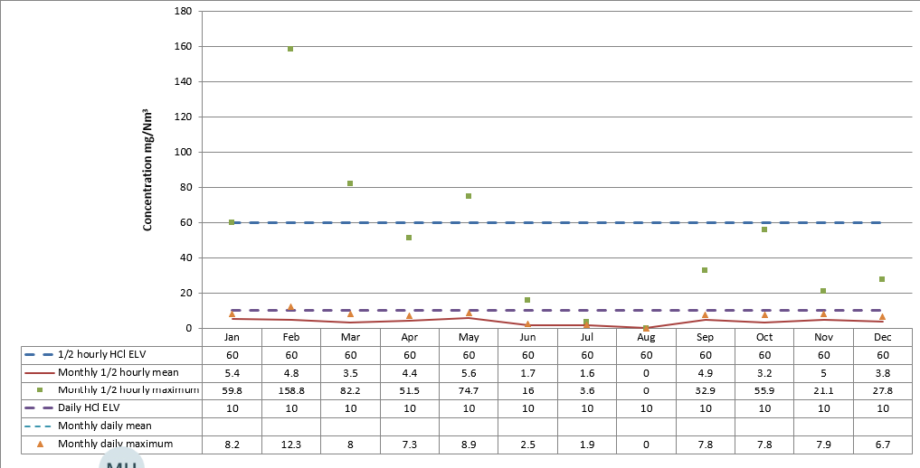

Line 1 – Sulphur dioxide

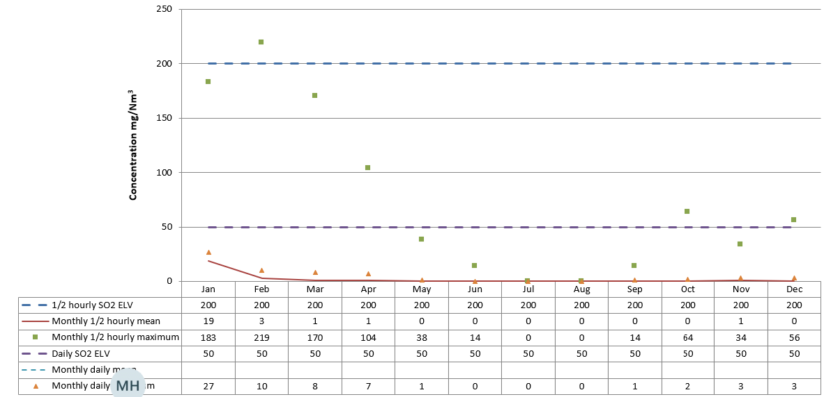

Line 1 – Oxides of nitrogen

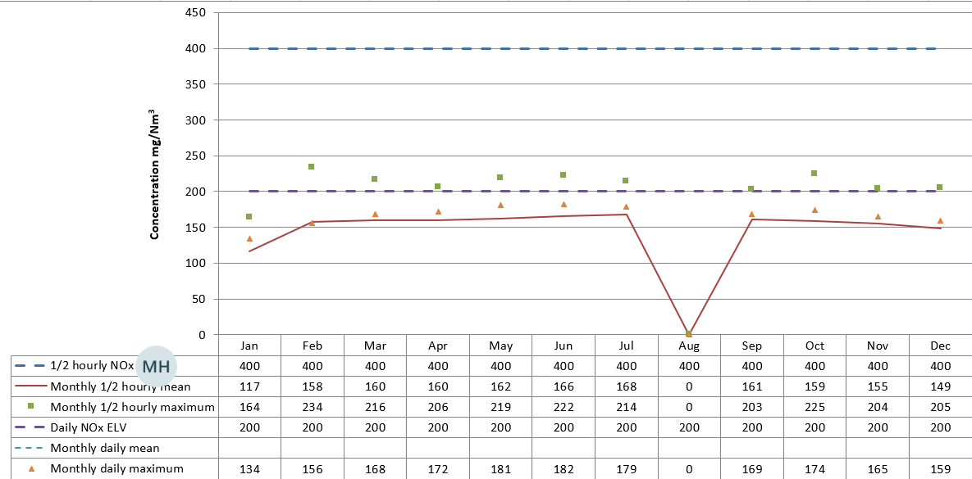

Line 1 – Total organic carbon

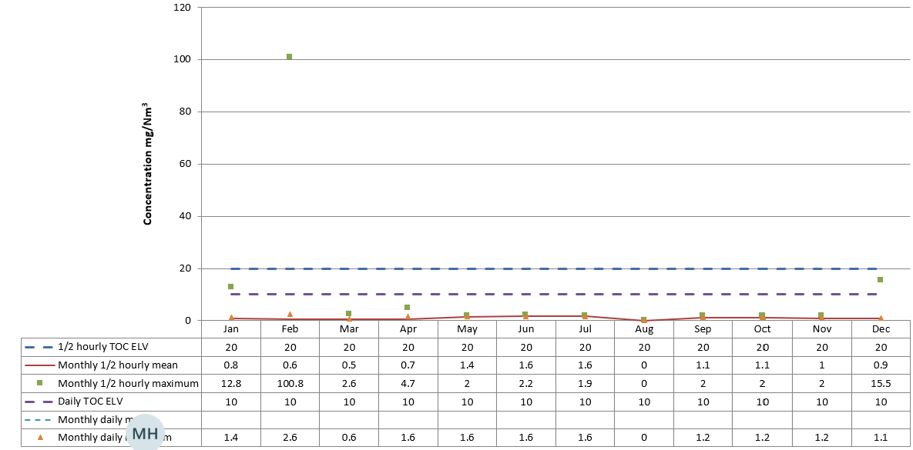

Line 1 – Particulates

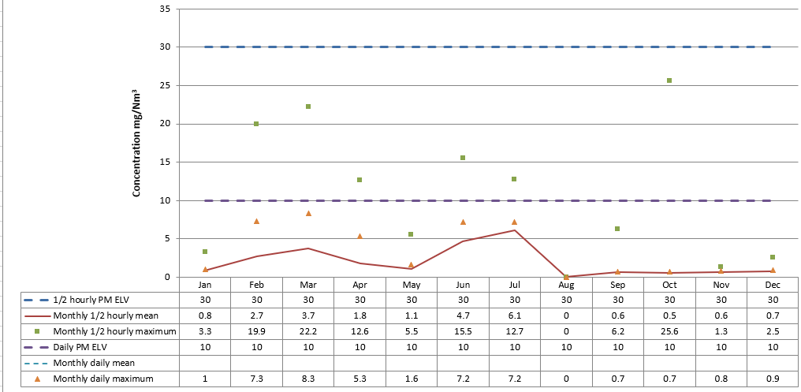

Line 1 – Carbon monoxide

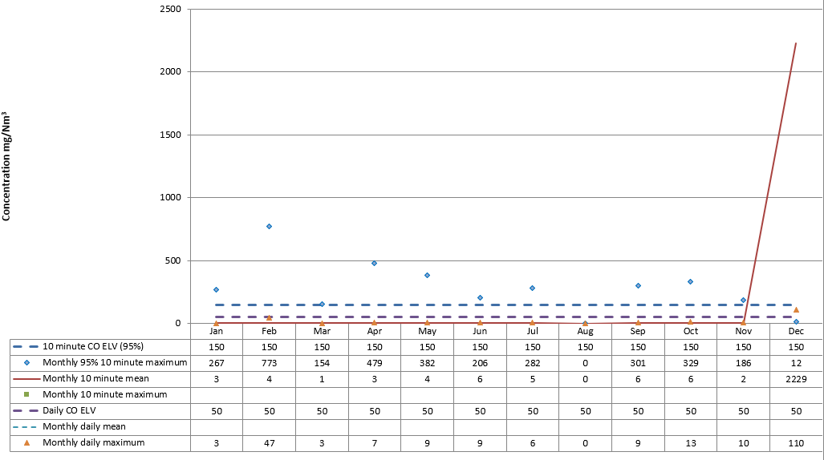

**4.2 Summary of periodic monitoring results for emissions to air**

The table below shows the results of periodically monitored substances.

|  |  |  |  |
| --- | --- | --- | --- |
| **Substance** | **Emission limit value** | **Results** | |
| 1st Half monitoring | 2nd Half Monitoring |
| Mercury and its compounds | 0.05 mg/m3 | 0.005mg/m3 | 0.0023mg/m3 |
| Cadmium & thallium and their compounds (total) | 0.05 mg/m3 | 0.004 mg/m3 | 0.0013mg/m3 |
| Sb, As, Pb, Cr, Co, Cu, Mn, Ni and V and their compounds (total) | 0.5 mg/m3 | 0.093mg/m3 | 0.0307mg/m3 |
| Dioxins and furans (I-TEQ) | 0.1 ng/m3 | 0.002mg/m3 | 0.000075mg/m3 |
| Hydrogen Fluoride | 2 mg/m3 | 0.047mg/m3 | 0.128mg/m3 |

**4.3 Summary of monitoring results for emissions to water**

There are no emissions to water from the process [other than clean surface water]

**5. Summary of Permit Compliance**

**5.1 Compliance with permit limits for continuously monitored pollutants**

The plant met its emission limits as shown in the table below.

|  |  |  |
| --- | --- | --- |
| **Substance** | **Percentage time compliant during operation** | |
|  | **Half-hourly limit** | **Daily limit** |
| **Particulates** | >99.99 % | >99.99 % |
| **Oxides of nitrogen** | >99.99 % | >99.99 % |
| **Sulphur dioxide** | >99.99 % | >99.99 % |
| **Carbon monoxide** | >99.99 % | >99.99 % |
| **Total organic carbon** | >99.99 % | >99.99 % |
| **Hydrogen chloride** | >99.99 % | >99.99 % |
| **Hydrogen fluoride** | >99.99 % | >99.99 % |

**5.2 Summary of any notifications or non-compliances under the permit**

|  |  |  |  |
| --- | --- | --- | --- |
| **Date** | **Summary of notification or non-compliance** | **Reason** | **Measures taken to prevent reoccurrence** |
| January 2022 | Exceedance of TOC Limit | Plant requires major works  See section 6 for further details | |
| 08/02/2022 | ERV Operation  (2minutes 33 sec) | Operator pressed the Emergency stop button | further guarding has now been placed over this to prevent accidental operation but is still accessible in an Emergency. |
| 10/02/2022 | Abnormal Operations  (180 minutes) | Restriction in the abatement plant dosing system. | Pipe agitated  Pipe is on a scheduled PPM. |
| 11/02/2022 | Abnormal Operations  (180 minutes) |
| 12/02/2022 | CO 95 ile and VOC exceedance | the waste loading ram got stuck in the extended position, so that the charging door could not close. | The plant was isolated, so that the restriction causing the Ram to stick was removed. Once this had been completed normal operation resumed. |
| 25/02/2022 | VOC exceedance | The emission exceedance was related to a change in the gas bottle for the analyser which created a zero off-set. The unit carries out an auto zero every hour, and emissions after this period are stable | |
| 08/03/2022 | ERV Operation and Fugitive Emission  (4 hours Burn out time) | Increased dust levels were identified and there was a visible plume from the stack. On investigation it appeared that there was a bag failure and both dust/other pollutants and reagents (hydrated lime/activated carbon) were passing through the baghouse | Manual abort of plant bring uncontrolled emissions under control as quickly as possible. |
| 22-03-2022 | Abnormal Operations  (30 minutes) | Restriction within lime feed pipe | The Restriction was removed, and the pipe checked. |
| March 2022 | Exceedance of TOC Limit | Plant requires major works  See section 6 for further details | |
| 10/04/2022 | ERV Operation  (5 Minutes) | ERV opened due to the ID fan Motor shutting down with an overcurrent fault. This follows the fitting of a new invertor which was part of our upgrade of the system. | We had a specialist company(Sulzer) To site to check the motor. The motor to fan support bearings and to rebalance the fan.. |
| 13/04/2022 | ERV Operation  (4 Minutes) |
| April 2022 | Exceedance of TOC Limit | 1st April, during which the following interim improvement works will be completed.   * Installation of new fingers in the primary chamber – to improve initial primary combustion * Re-drill under fire air holes in the primary chamber hearth – to improve primary combustion * Inspection of the filters in the baghouse – for preventative maintenance purposes * Inspect and clear out of the throat & stage 2/3 – preventative maintenance and to improve draught * Replacement of the seals in the lime silo – for preventative maintenance and to improve draught * Install a new inverter on the ID fan – for preventative maintenance and to improve draught | |
| May 2022 | Exceedance of TOC Limit |
| June 2022 | Exceedance of TOC Limit | Plant requires major works  See section 6 for further details | |
| July 2022 | Exceedance of TOC Limit | Plant requires major works  See section 6 for further details | |
| 08-12-2022 | COmg/m3 emitted to air | Fault with main gas supply to site. | We have bypassed a faulty gas governor and are awaiting a replacement. |
| 09-12-2022 | COmg/m3 emitted to air |

**5.3 Summary of any complaints received and actions to taken to resolve them.**

|  |  |  |  |
| --- | --- | --- | --- |
| **Date of complaint** | **Summary of complaint** | **Reason for complaint including whether substantiated by the operator or the EA** | **If substantiated, measures to prevent reoccurrence** |
| 2022 | None Received. |  |  |

**6. Summary of plant improvements**

|  |
| --- |
| **Summary of any permit improvement conditions that have been completed within the year and the resulting environmental benefits.** |
| None. |
| **Summary of any changes to the plant or operating techniques which required a variation to the permit and a summary of the resulting environmental impact.** |
| None. |
| **Summary of any other improvements made to the plant or planned to be made and a summary of the resulting environmental benefits.** |
| During 2022 the plant was off line for major maintenance which included:   * Full re-line of the primary chamber hearth * Replacement of the primary chamber water seals and under fire injection holes * Replacement of ducting to the quench tower, reactor tower and bag house * Rebuild of the front-end loader and associated steelwork (replace the hopper floor, walls & hood) * Refractory replacement in both combustion chambers and the throat between the primary and secondary chambers |